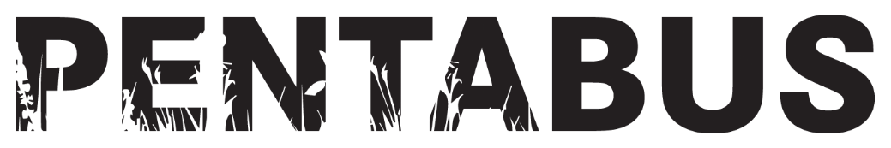APPLICATION FORM
Pentabus Local Young Writers (2025)

ABOUT YOU
Pronouns | First name |  | Surname
Date of birth
Email |  | Phone number
Do you live, work or learn in Shropshire or the West Midlands? (Delete as appropriate)
Yes / No

Home address and post code
Place of work (if applicable)
Place of study (if applicable)
How easy is it for you to get to sessions in Ludlow? (Delete as appropriate, and feel free to expand on your answer)
Very easy / Quite easy / Tricky but doable / Really difficult

GETTING TO KNOW YOU

Please tell us why you have applied for this opportunity and what you most hope to gain or achieve from the programme? (Max 100 words)
What significance does the idea of ‘rural’ have to you? Do you have links to, or experience of, the rural? (Max 100 words)

YOUR WRITING

Please note: It is not a requirement that you have an example of your own playwriting to be able to apply for Young Writers: Local. You are welcome to send us anything you have written before that demonstrates your creativity with words, narrative, dialogue, plot etc.

If you don’t feel you have something that you can include, you can either draft something new and original in the box below, or leave it blank. Either way, your application will still be considered.

Please copy and paste a sample of your playwriting (1 – 10 pages max) in the box below (which we expect will need to expand to accommodate your work), or attach as a separate Word document or PDF along with your application.

Thank you for taking the time to complete an application for our Local Young Writers 2025 course. Please submit this form and any additional documents to Joanna Freeman (Head of Engagement) on joanna@pentabus.co.uk by 9.00am on Monday 16th December 2024.
We aim to be back in touch with all applicants, whether or not you are successful.

